Solution Architecture
Date | 24 June 2026
Name | Dinesh S
Project Name | CampusMind AI – Smart Campus Incident Management System
Maximum Marks | 4 Marks
Solution Architecture
CampusMind AI is a ServiceNow-based Smart Campus Incident Management System that automates the complete campus incident lifecycle. The application enables students and staff to report campus issues through a user-friendly Student Portal, while administrators and support teams efficiently manage, assign, monitor, and resolve incidents.
The system integrates Record Producers, Business Rules, Client Scripts, UI Policies, Flow Designer, SLA Management, Escalation, Email Notifications, Reports, and Interactive Dashboards to automate incident handling from submission to closure. Role-Based Access Control (RBAC) using User Roles and ACLs ensures that each user can access only the appropriate modules and records according to their responsibilities. Automated assignment, SLA tracking, and notification services improve response time, operational efficiency, and transparency across the campus support process.

Key Objectives
- Centralize campus incident reporting through a Student Portal.
- Automate incident assignment and workflow management.
- Implement secure Role-Based Access Control using ACLs.
- Monitor incidents using SLA tracking and automatic escalation.
- Send automated email notifications during the incident lifecycle.
- Provide interactive dashboards and reports for administrators.
- Improve campus service efficiency, transparency, and user satisfaction.
- Enhance decision-making using intelligent automation and future AI-based incident prediction.

Solution Architecture Diagram
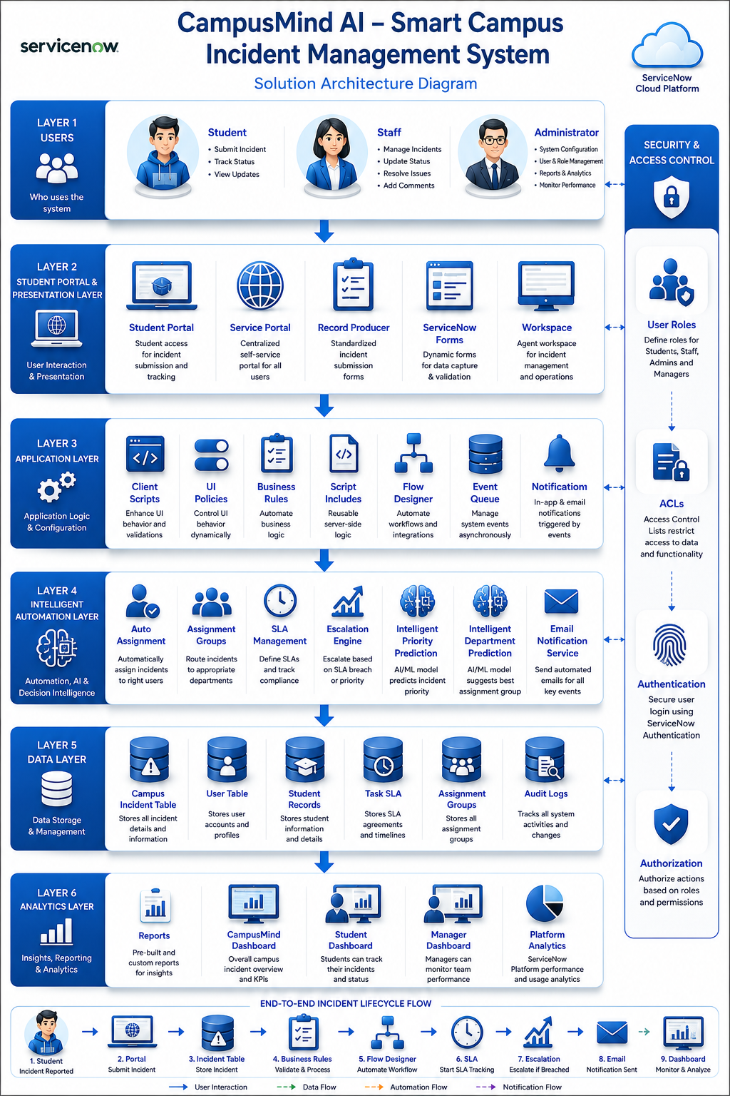

Figure 1: Solution Architecture for CampusMind AI – Smart Campus Incident Management System

Reference
Lucidchart Architecture Guide
https://www.lucidchart.com/pages/system-architecture-diagram

